Details of Person/Organisation Making Booking
Name: Organisation: Address:

Postcode: Home Telephone: Mobile Telephone: Email Address: Account to be sent to (if different from above):

Forest Row Community Centre Booking Form
Name | Dates | Start and End Time
If you are a regular hirer, please note any dates you do not want here:
Type of function: Number of people expected: Hire of:
Main Hall | Treatment Room
Garden Room | Kitchen
Rose Room | Kitchen for drinks only
Spring Room | Community Office

Do you require any of the following additional items?
Glass | Flipchart (pens included)
China | Staging Units
Water Urn | Projector Screen

I have read and accept the terms and conditions of hire as

detailed.

Signed:

Date:
Do you have public liability insurance?
Do you intend to bring any electrical equipment?
YES / NO
YES / NO
NB: Under the terms of the Licensing Act we will require a minimum of two weeks notice if you intend to sell alcohol other than at a private ‘closed’ event, such as a
family party. You will have to obtain a Temporary Events Notice from Wealden District Council.

Layout of Function
Please outline below the layout you require for your function
Forest Row Parish Council

The Community Centre Hartfield Road
Forest Row East Sussex RH18 5DZ
Tel: 01342 822661
Email: info@forestrow.gov.uk

Number of tables required: | Type of table: ROUND/TRESTLE
Number of chairs required: | Clear room needed: YES/NO

Tables, chairs, crockery, cutlery and other items are available for hire off the premises.
For a full list of items and prices please ask for details.

Please note that no smoking is allowed inside the buildings.

Forest Row Parish Council takes your privacy seriously and will only use your personal information to administer your account and to provide the products and services you have requested from us.
We will not share your details with third parties but may wish to contact you about other services or events that we are holding. If you consent to us con- tacting you, please tick to say how you would like us to contact you.
Post Email Telephone

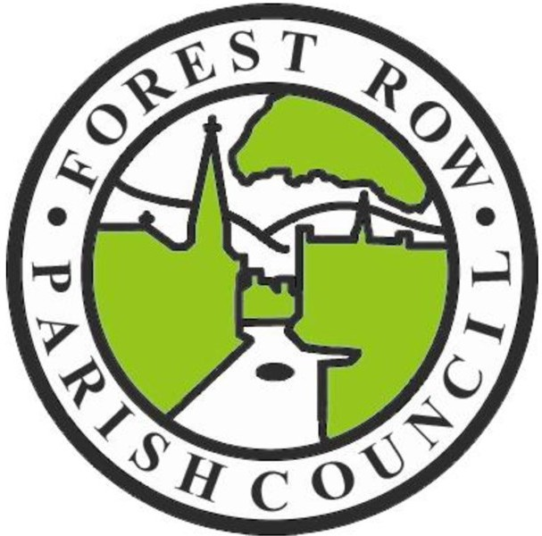

BOOKING FORM

For the hire of rooms in the Community Centre

